Suggested newsletter text: Summer Reading Challenge 2024 in Inspire Nottinghamshire Libraries
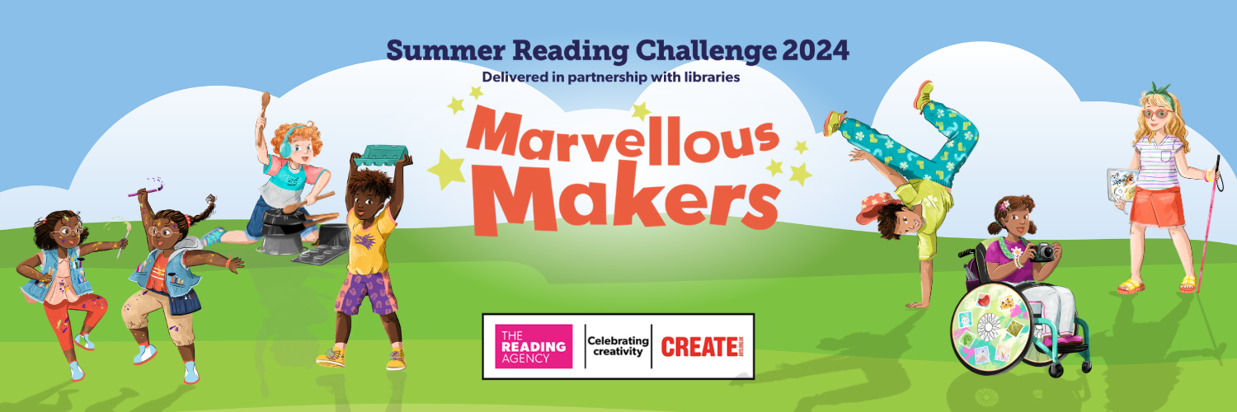

Summer Reading Challenge 2024, Marvellous Makers at Inspire libraries
6 July - 1 September

Libraries in Nottinghamshire are looking forward to a summer filled with reading and creativity as the Summer Reading Challenge returns this July.

Produced by The Reading Agency and run in libraries across the country, the Summer Reading Challenge is a brilliant way to maintain children’s reading enthusiasm throughout the summer break.

Children are challenged to read six library books over the summer collecting rewards …including smelly stickers…. along the way. Every child who completes the challenge will receive a certificate and medal.

Children choose the books they want to read; story books, fact books, poetry, joke books –all reading counts!

This year children are invited to join the Marvellous Makers who are busy getting creative for a big festival…but the objects they need have mysteriously disappeared. By reading books children will help our creative friends find the objects they need to complete their creations.

Marvellous Makers is running in all Inspire libraries until Sunday 1 September, for children aged 4 – 11. It’s completely FREE to take part. Ask in your local library anytime after Saturday 6th July to sign up.

Find out more at www.inspireculture.org.uk/summerreadingchallenge

Summer Reading Challenge 2024, Marvellous Makers at Inspire libraries
6 July - 1 September

Join the Marvellous Makers for the FREE Summer Reading Challenge 2024 and earn rewards for reading. Ask in your library any time from 6th July to sign up.

www.inspireculture.org.uk/summerreadingchallenge

