**Artist Brief: I Am An Artist**

**What is I Am An Artist?**

I Am An Artist is the second branch of our three-year [I Am A Creator](https://www.inspireculture.org.uk/reading-information/reading/i-am-a-creator/) cultural programme and will be part of [The Big Draw 2024.](https://thebigdraw.org/) I Am A Creator is funded by investment from [Arts Council England](https://www.artscouncil.org.uk/), through our status as an [ACE National Portfolio Organisation](https://www.artscouncil.org.uk/NationalPortfolio23).

This programme will see us working with libraries across the county and targeted groups in Bassetlaw, Ashfield, Mansfield and Newark & Sherwood.

Our target groups are:

* People affected by dementia
* Older people
* SEND schools
* Neurodivergent families
* Wider public audiences, including audiences that can be/feel excluded from the arts

**What we want:**

We are open to creative approaches in any artform. We are looking for five creatively curious artists to:

* Develop their practice by attending paid Continuing Professional Development (CPD)
* Work collaboratively with Inspire, our partners, and other artists on the project
* Engage creatively with our target audiences to co-create original artworks

**Our aims are to:**

* Support the creative development of artists
* Engage and inspire audiences to explore their creativity
* Make great co-created artwork
* Tour the work to Library Galleries
* Be part of The Big Draw 2024

**Our outcomes are to:**

* Build strong and mutually beneficial connections with our target audiences, by delivering collaborative workshops in libraries and community settings
* Inspire co-created artwork in any medium
* Create an exhibition

**Timeline:**

* CPD and planning opportunities will take place during June 2024
* Workshop delivery will take place between July and October 2024
* Library exhibition dates:

|  |  |  |  |  |
| --- | --- | --- | --- | --- |
| Worksop | Saturday | 05 October 2024 | Wednesday | 13 November 2024 |
| Beeston | Saturday | 16 November 2024 | Sunday | 05 January 2025 |
| West Bridgford | Wednesday | 08 January 2025 | Wednesday | 12 February 2025 |
| Mansfield | Saturday | 15 February 2025 | Sunday | 30 March 2025 |

[inspireculture.org.uk/galleries](http://www.inspireculture.org.uk/galleries)

**Fee:**

* Each target group will have 4 (half day) artist workshops
* Each library will have one (half day) artist workshop
* CPD workshops will be paid

Rate **£250 per workshop**, this includes expected preparation time. Workshops will be shared between the selected artists. Budget for travel, materials, access costs and to ensure quality creative outcome suitable for exhibition from each group is available and will be negotiated. There is no additional budget for accommodation.

**Application process:**

Submissions should be made by **9am** on **Tuesday 28 May** to [arts@inspireculture.org.uk](mailto:arts@inspireculture.org.uk)

**What we need from you:**

1. Your creative response. Below are some prompts to help you think about what you might tell/show us:

* How will you engage the audience?
* What could you do?
* How will you deliver it?
* What will you need?
* What could it produce?

1. Your credentials in the form of past work. We want to work with new and/or established artists but would like to see some examples of your work that will help us know more about your practice. This might be:

* Weblinks
* Photos
* Social Media account links
* Book titles
* Podcasts
* Something else…?

We will accept any form of application:

* Written (Max one side of A4)
* Audio (Max 2 mins)
* Drawn (Max A2)
* Filmed (Max 2 mins)
* Something else…?

**And finally:**

We are committed to attracting and recruiting diverse candidates and welcome applications from underrepresented groups.

If you require Inspire to make any reasonable adjustments to the process of receiving your ideas and make it more accessible for you, please contact: [arts@inspireculture.org.uk](mailto:arts@inspireculture.org.uk)

Thank you for taking the time to review this brief.

**Further information:**

[Inspire: Culture, Learning and Libraries](http://Inspireculture.org.uk) is a charitable community benefit society delivering cultural and learning services across Nottinghamshire. Our mission is: “To inspire people to read, learn and enjoy culture”.

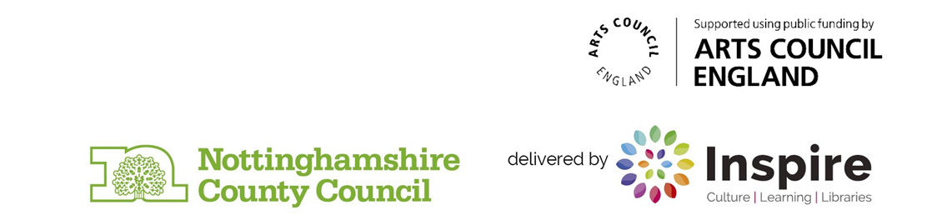[The Big Draw Festival](http://thebigdraw.org) is a worldwide celebration of drawing! The Big Draw promote the universal language of drawing as a tool for learning, expression, and invention. They are the founder and driving force behind The Big Draw Festival, which is a major component of their work in encouraging people to get back to the drawing board! The festival is made up of a collection of thousands of creative events, activities, and workshops across the globe run by organisations big and small, from individuals to entire cities!